Lab 7: Navigating the Filesystem
Pwd
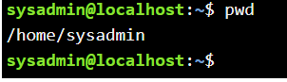

echo $HOME
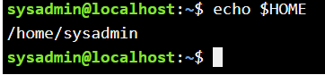

cd /
pwd
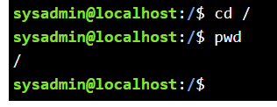

cd
pwd
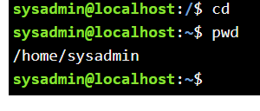

cd /home
pwd
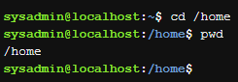

cd ~
pwd

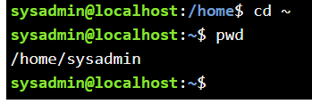

echo ~ ~sysadmin ~root ~mail ~nobody
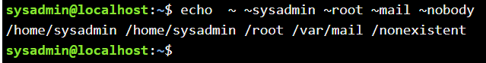

cd ~root
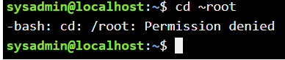

cd /usr/bin
pwd
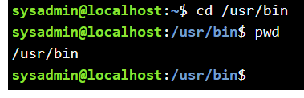
cd /usr
pwd
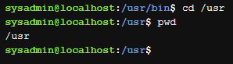

cd /usr/share/doc
pwd
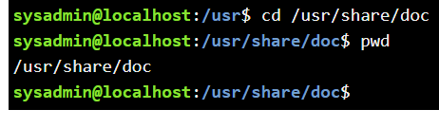

cd bash
pwd
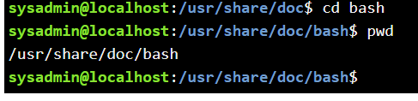

cd ..
pwd
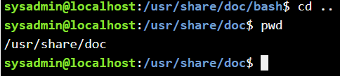

cd ../dict
pwd
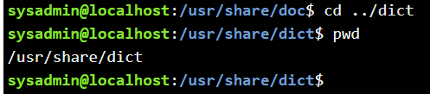

cd
ls
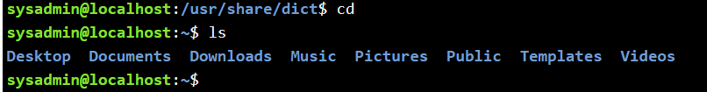

ls –a
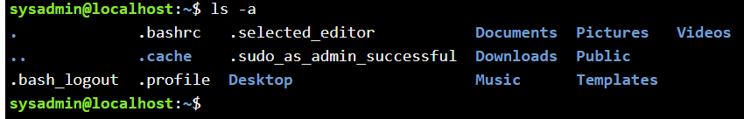

ls -l /etc/hosts
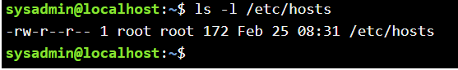

ls -R /etc/udev
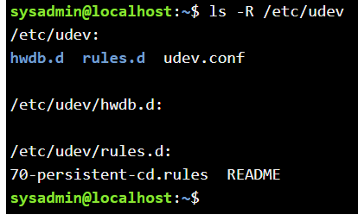

ls -d /etc/s*
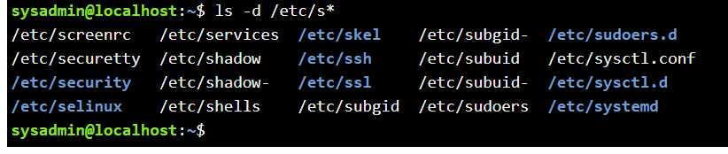

ls -d /etc/????
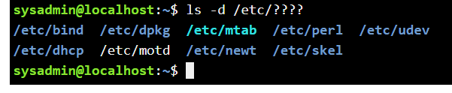

ls –d /etc/[abcd]*
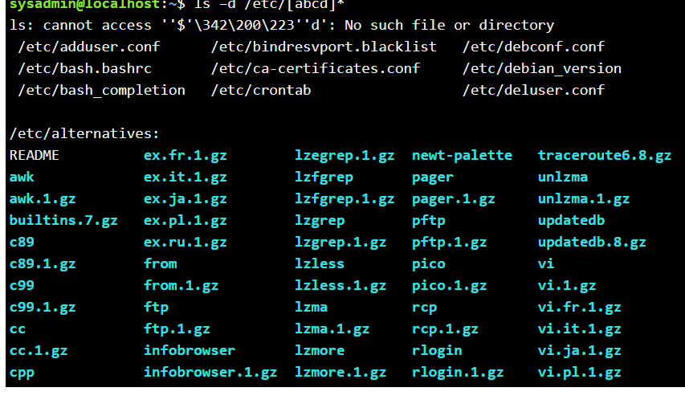

echo *
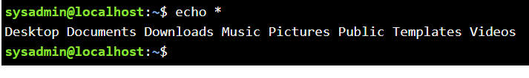

echo D*
echo P*
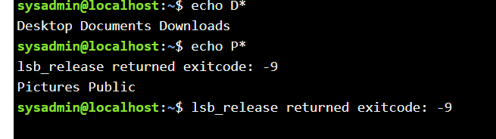

echo *s
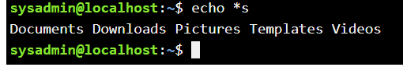

echo D*n*s
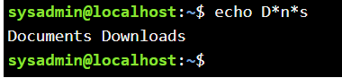

echo ??????
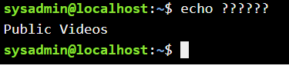

echo D????????
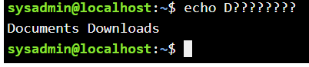

echo ?????*s
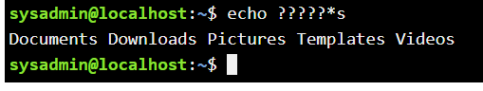

echo [DP]*
echo [!DP]*
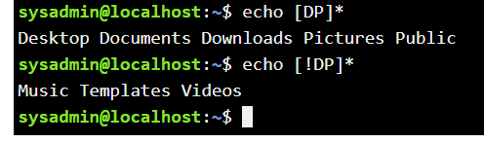

echo [D-P]*
echo [!D-P]*
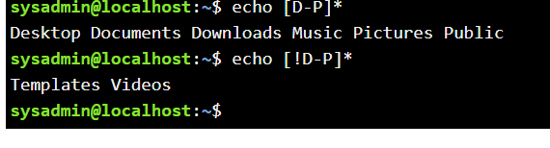

ls
cp /etc/hosts hosts
ls
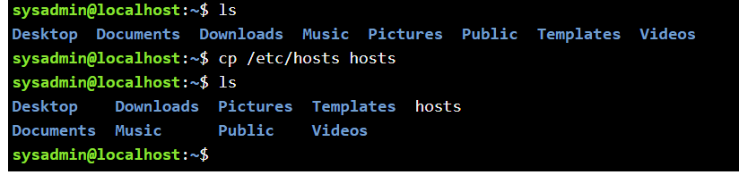

rm hosts
ls
cp –v /etc/hosts hosts
ls
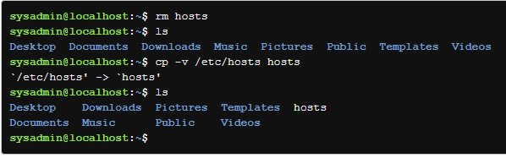

rm hosts
ls
cp –v /etc/hosts .
ls
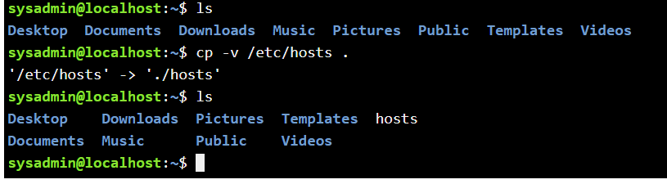

rm hosts
ls
cd /etc
ls -l hosts
cp –p hosts /home/sysadmin
cd
ls –l hosts
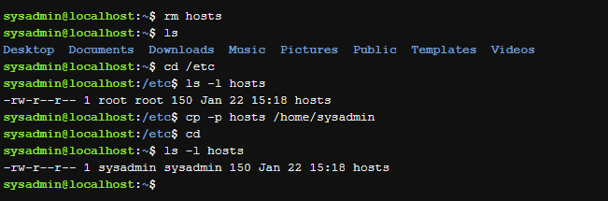

rm hosts
cp -p /etc/hosts ~
cp hosts newname
ls –l hosts newname
rm hosts newname
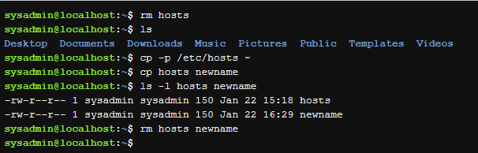

mkdir Myetc
cp –R /etc/udev Myetc
ls –l Myetc
ls –lR Myetc
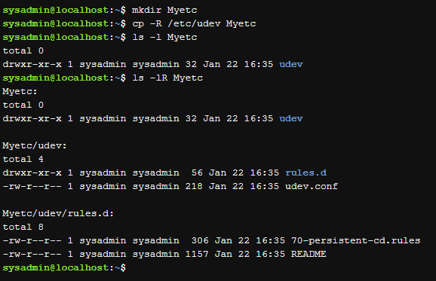

ls
rm -r Myetc
ls
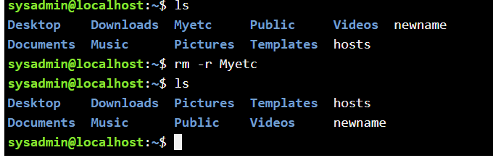

touch premove
ls
mv premove postmove
ls
rm postmove
